DURATION: 2 Hours

THERIC CONTENTS

* Lesson 2. Algorithms.
* Lesson 3. Data Types.
* Lesson 4. Operators and Expressions.
* Lesson 5. Input and Output.
* Lesson 6. Flow Control Selection.

GITHUB CLASSROOM ASSIGNMENT

https://classroom.github.com/a/KZ0BWni7

PROPOSED EXERCISES

Exercise 1. Design and implement in C an algorithm that displays the absolute value of a number that must be given by the user. See below the definition of absolute value of a number x.



Exercise 2. Design and implement in C an algorithm that Solve a simple equation

**aX + b = 0.**

If a is equal to 0 and b is not equal to 0 then the solution is not feasible.

If a is equal to 0 and b is equal to 0 then the solution is indeterminate

Exercise 3.Design and implement a C program that simulates a basic calculator through the following steps:

1. Select one of these options: sum, subtraction, multiplication or division.
2. Ask two integer numbers.
3. Perform the corresponding operation.
4. Show the result.

**Note:** Division by zero is not feasible

|  |  |
| --- | --- |
|  |  |

Exercise 4. Design and implement in C an algorithm that reads data of a student (name, NIF, age and credits) from a text file (ficha.txt). After that, the program reads the information from this file and writes the student's name in other text file named “user.txt” only if the student is greater than 18 years old or has less 30 credits.

* Example Input File:

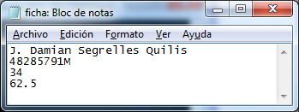

* Example output File:

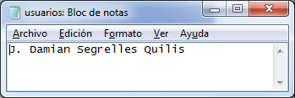

Exercise 5. Design and Implement in C an algorithm in which the user inputs a student's name, name of a subject and the mark of the student in the subject.

The algorithm have to save in an output text file(ex5_alu.txt) the name of the student, the name of the subject and its qualification in function of this table:

Mark Qualification

[0,5[ Falied

[5,7[ Passed

[7,9[ Notable

[9,10[ Excelent

1. MH

The name of the output file has to be asked to the user.

If the mark is less than 0 or greater than 10, the qualification will not to be wrote in the output file.

|  |  |
| --- | --- |
|  |  |

Exercise 6. One year is a *leap year* if it is multiple of 4 and it is not multiple of 100, unless it also is multiple of 400.

Design and implement a program in C that asks to the user one value, which must be between 1500 and 2050. If the user enters a value out of this range, the program must display the following message: “Value out of range”. Otherwise, the program must display whether the value is a leap year or not.

Examples:





